Bee Venom Investigation

Introduction
Approximately 5% of the Western population suffers from bee sting allergies. Some of these reactions can lead to anaphylactic shock, a life-threatening situation requiring the administration of adrenalin. Other reactions are mild with symptomatic rashes. Allergies are an immune response to an antigen. In this case inflammation in the response and bee venom is the antigen. This investigation hopes to show a relationship between the concentration of bee venom and the severity of the allergic reaction. The size of the reaction will be indicated by the size of skin inflammation. It is hypothesised that the greater the concentration of bee venom injected, the greater the size of the rash that will develop.

Materials:
Bee venom –
0.05%
0.10%
0.15%
Grid on transparent film
Syringe

Participants:
Participants were 18-year-old students from Fictitious College and all were selected because they had previously shown signs of mild allergic reactions to bee venom. The group consisted of 54 male students and 46 females. The participants’ Body Mass Indexes were within healthy norms, and full medical checks were administered prior to the experiment. Paramedics were present during the experiment to treat any unforeseen medical complications. Males and females were tested to ensure validity between genders.

Procedure:
- Participants were randomly organised into four groups.
- Group 1 acted as the control group and was injected with saline.
- Group 2, 3 and 4 were inject with 0.05%, 0.1% and 0.15% of bee venom respectively
- Venom was administered via syringe just a few millimetres into the skin of the right forearm
- Participants were observed for 60 minutes, during which time participants were to self-examine for signs of skin inflammation
- At sites of inflammation, a grid printed on transparent film was used to count the affected area in squared centimetres.

Results:
Areas of skin inflammation ranged from 0 - 34 cm². As Table 1 illustrates, there is a strong relationship between the concentration of bee venom and the dimensions of skin irritation that develop. Scores for both genders were similar.

Table 1. Average area of skin inflammation of males and females

 | Average size of rash (cm²)
Dose of bee venom | Male | Female
Control group – no venom | 0 | 0
0.05% | 7 | 8
0.10% | 12 | 14
0.15% | 20 | 19

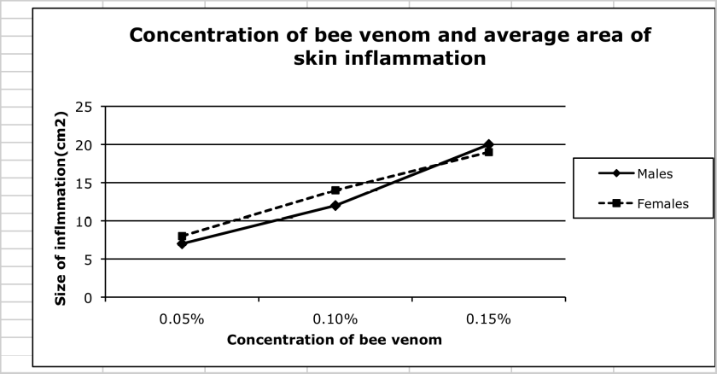

Discussion & Conclusion:

The hypothesis that a greater concentration of bee venom will elicit a greater area of skin inflammation was supported by these results. As less venom has entered the body, the smaller the immune response the body would have to mount. The large range in results would indicate the size of immune responses also varied within each group. This could be because prior history of bee allergies had not been controlled for stringently. Future tests would need to limit how many exposures participants had to bee stings. Subsequent exposures to the venom tend to bring about stronger immune responses each time.

It would be worthwhile having a larger sample size of people to test, possibly of different ages. Whilst age was controlled for, other age groups should be tested. Other allergens could also be tested as this hypothesis might yield similar results for other allergic immune responses.

Applications of these findings are applicable to identifying those susceptible to allergies as well as desensitisation treatments to prevent life-threatening reactions.

